PUBLIC NOTICE
NOTICE OF REZONING
The District of 100 Mile House is considering initial readings of Zoning Amendment Bylaw No. 1421, 2024.
The purpose of Bylaw 1421, 2024 is to add ‘secondary suite’ as an Accessory Permitted Use to the A-3 Zone; and make text amendments to include verbiage regarding waiver or prohibition of Public Hearings. These amendments are being considered to comply with the requirements of Bill 44 legislation.

Council of the District of 100 Mile House will consider first, second and third reading of Bylaw 1421, 2024 on April 23rd, 2024 at 5:00 pm in the Municipal Council Chambers, located at 385 Birch Avenue (Fourth Street entrance), 100 Mile House. No Public Hearing will be held.

Subject Properties: All properties zoned Resource Area (A-3) Zone.
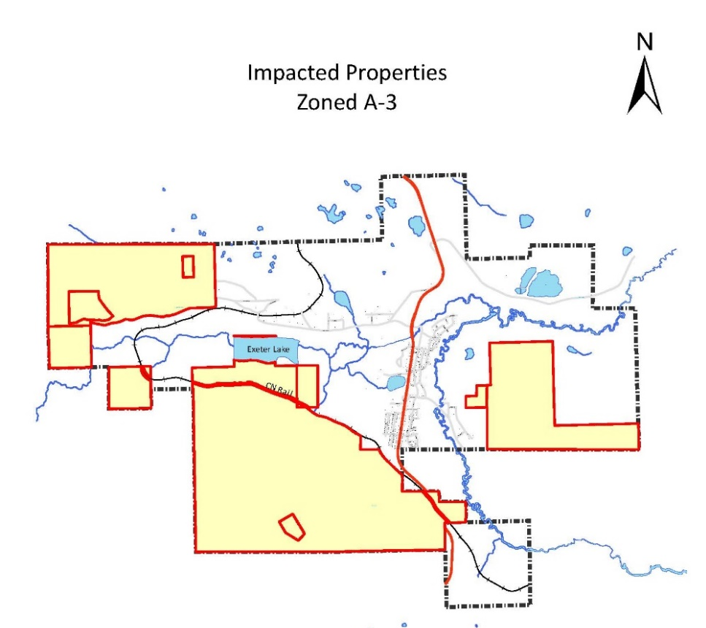
The proposed bylaw may be inspected during normal working hours in the Municipal Office, 385 Birch Avenue from the date of this notice until 4:00 p.m. April 23rd, 2024.

If you require information regarding this bylaw, please contact the undersigned at 250-395-2434.
Joanne Doddridge
Director of Economic Development & Planning

